**Brooklyn torah gazette**

**For parshas emor 5783**

Volume 7, Issue 33 (Whole Number 340) 15 Iyaar 5783/ May 6, 2023

**Printed L’illuy nishmas Nechama bas R’ Noach, a”h**

For a free subscription, please forward your request to [***keren18@juno.com***](mailto:keren18@juno.com)

**Are Jews Overly**

**Obsessed with Money?**

**By Daniel Keren**

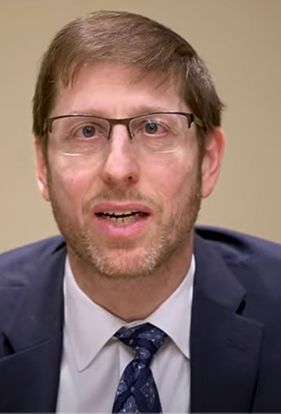

**Rabbi Kenneth Jeremy Wieder**

Are Jews overly obsessed with money? That is actually the title of most recent Living L’Chaim Kosher Money podcast released on April 18th where the show’s host Eli Langer interviewed Rabbi Kenneth Jeremy Wieder.

According to Wikipedia, Kenneth Jeremy Wieder (born February 1971, is a [Rosh Yeshiva](https://en.wikipedia.org/wiki/Rosh_yeshiva) at the [Rabbi Isaac Elchanan Theological Seminary](https://en.wikipedia.org/wiki/Rabbi_Isaac_Elchanan_Theological_Seminary) (RIETS) of [Yeshiva University](https://en.wikipedia.org/wiki/Yeshiva_University), located in the [Washington Heights](https://en.wikipedia.org/wiki/Washington_Heights,_Manhattan) neighborhood in Manhattan. He holds the Gwendolyn and Joseph Straus Chair in Talmud.

Rabbi Wieder was one of the first Americans to win the [International Bible Contest](https://en.wikipedia.org/wiki/International_Bible_Contest), and later graduated [summa cum laude](https://en.wikipedia.org/wiki/Summa_cum_laude) from [Yeshiva College](https://en.wikipedia.org/wiki/Yeshiva_University) in 1991, and received an M.S. in [American Jewish history](https://en.wikipedia.org/wiki/American_Jewish_history) from the [Bernard Revel Graduate School of Jewish Studies](https://en.wikipedia.org/wiki/Bernard_Revel_Graduate_School_of_Jewish_Studies). In 2005, he received a PhD in Hebrew and Judaic Studies at [New York University](https://en.wikipedia.org/wiki/New_York_University). He is a resident of [Teaneck, New Jersey](https://en.wikipedia.org/wiki/Teaneck,_New_Jersey), where he lives with his wife and two children.

**The Existential Issue of Materialism and Economics**

Some of the interesting points brought up by Rabbi Wieder in this highly relevant podcast interview are as follows:

The issue of materialism and economics according to Rabbi Wieder is an existential issue for 99% of the Modern Orthodox Jewish community. Unless one was born into wealth, money is really a constant struggle. For some more or for some less, but still a major struggle. In his opinion, the struggle to earn enough money for the basic lifestyle threatens the existence of “our community” (the Modern Orthodox) as an ongoing entity.

Rabbi Wieder further emphasized that this need for those in the Modern Orthodox community to earn sufficient income ties into the question of being able to afford yeshiva tuition.

When questioned about that 1% of the community that is wealthy, Rabbi Wieder emphasized that he didn’t mean to say that they don’t have problems, but only that their problems are not related to having money. As the Gemora in Moed Katan teaches us that there are three things – length of life, having children, or creating a good name that are not entirely dependent on a person’s own actions or efforts.

**A Very Serious Challenge**

The basic challenge for every individual, Rabbi Wieder pointed out is to be able to support oneself and that includes being able to have enough food, clothing and a roof over one’s head at a minimum level. And for many people today in our community that has become a very serious challenge.

It certainly seems that someone who has less may be more reliant on G-d and hence be able to develop a stronger connection in that direction. Although according to Rabbi Wieder there are certainly poor people who are so stressed by their financial difficulties that they don’t know how to rely on G-d and there are also wealthy people who do know how to put their financial blessings in the proper prospective vis a vis their relationship with G-d.

When asked by Eli Langer if the process of becoming wealthy changes a person’s personality, Rabbi Wieder noted a study by the Harvard Business School that one who become wealthy does have a serious challenge. The study utilized images of the brain of those who became wealthy and powerful and it discovered an interesting paradox. As people became wealthy and hence more powerful, their brains did change and one of those changes was a tendency to weaken one’s trait of empathy or compassion for those less fortunate.

**Poorer People Give a Higher**

**Percentage of the Income to Charity**

It is not surprising, Rabbi Wieder says, that when studies have been made of the percentage people give to charity, poor people proportionately give a higher percentage of their income than the wealthy on average. This is because they still feel connected to those who are struggling.

One offshoot of the struggle of many in the Jewish community to earn enough money to pay their obligations is the very high cost of yeshiva tuition. Rabbi Wieder believes that in all of the Jewish communities in America there are enough wealthy Orthodox Jews who could cover most of the cost of yeshiva education and there is a moral responsibility for this segment of the population to step up to plate and relieve the crushing burden from most of the parents.

**An Obligation for the Wealthy People**

Also, many people in our community are struggling to keep up with a lifestyle that they feel is necessary in order to maintain their dignity or self-respect, although it would be perhaps be considered luxurious by our grandparents. Rabbi Wieder said even if wealthy people in our communities give their full 20% (chomesh) of their earnings to tzedakah, they still have an obligation to at least not on the outside display a lifestyle that the rest of the community cannot comfortably match.

To listen or watch this podcast and learn other insightful concepts from Rabbi Wieder you can google the podcast – Are Jews Overly Obsessed with Money or <https://youtu.be/t8CprH5HYeY>

*Reprinted from the April 28, 2023 edition of The Jewish Connection.*

**The Obligation of a Jew to Love Each and Every Fellow Jew**

**From the Teachings of the Lubavitcher Rebbe**

**Rabbi Menachem Mendel Schneerson, Zt”l**

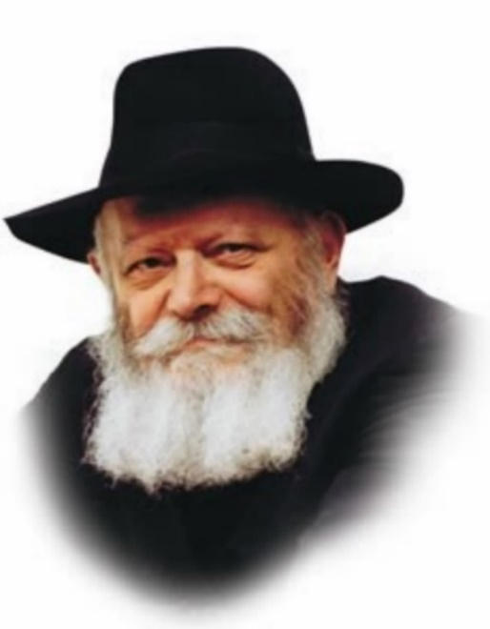

The name of this week's Torah reading, Emor, contains a lesson for every Jew. "Emor -- Say" the Torah commands every Jew. The power of speech entails a certain responsibility we must always be aware of every time we open our mouths.

The Midrash explains that all of G-d's utterances are amarot tehorot, "pure statements." Whatever G-d says comes into being, unlike the statements of a fleshly king, who may promise the world but not necessarily fulfill his pledge. G-d is the essence of truth, and His utterances endure forever.

As every Jew is intimately connected to G-d, his statements share this same quality of endurance. Every Jew must therefore be extremely careful when he speaks, and refrain from saying anything negative about his fellow Jew.

The Torah portion of Emor teaches us to speak only positively about other Jews. As Maimonides puts it, "It is a mitzva to love each and every Jew...therefore, one must speak [only] of his praise."

Maimonides writes that a talmid chacham (Torah scholar) "extols the virtue of his fellow and does not denigrate him." Every Jew is similarly obligated to say only kind things about others, and not, G-d forbid, speak evil of his fellow man.

Even if we see a Jew doing something wrong we must always judge him favorably and try to understand what caused him to sin. We must never defame his character or mention his transgression.

Just as G-d's utterances are "pure," abiding forever, so too do our positive statements about other Jews exert a lasting and powerful influence. The very act of praising another Jew serves to reveal the innate good that is hidden inside him, and causes him to want to live up to the words of praise.

Emor is read during sefirat ha'omer, the counting of the omer. These days are a period of mourning for the 24,000 disciples of Rabbi Akiva who passed away because they did not treat each other with the proper respect.

Counting the omer reminds us to stop speaking about other Jews in an unfavorable light. Similarly, Emor reminds us to speak favorably about our fellow Jews.

"Emor!" the Torah enjoins us. Say only good about another person!

*Adapted from Likutei Sichot, Volume 27*

*Reprinted from the Parshat Emor 5758/1998 edition of L’Chaim (Issue #518), a publication of the Lubavitch Youth Organization in Brooklyn, NY.*

**Thoughts that Count**

*None of them shall defile himself, among his people (b'amav)* (Lev. 21:1)

The Hebrew word "amav" is related to the word "im'um," dimming or growing dark, as in dying embers or coals that have been left to burn out on their own. Serving G-d "dimly," halfheartedly and without fervor, is the cause of all defilement and impurity. The Torah warns us against allowing our G-dly spark to grow dim. Rather, it must be constantly nurtured and rekindled. *(The Rebbe of Alexander)*

*You shall not profane My holy name* (Lev. 22:32)

When a Jew does a mitzva purely and simply for the sake of G-d, without an ulterior or self-serving motive, he sanctifies G-d's Name. When one hears only positive things about a person, that too is a sanctification of G-d's Name. Conversely, G-d's Name is profaned when negative comments are made about a person-even if he has a legitimate excuse for his behavior. *(Maimonides, Igeret HaShmad)*

*Reprinted from the Parshat Emor 5758/1998 edition of L’Chaim (Issue #518), a publication of the Lubavitch Youth Organization in Brooklyn, NY.*

**Rabbi Berel Wein on**

**Parshas Emor 5783**

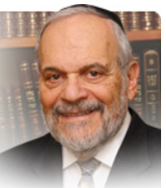

We can all agree that the priestly family of Aharon has always had a special rank and position within the Jewish people. Having been chosen to represent G-d to the Jewish people and the Jewish people to G-d, so to speak, they had a decisive role of influence within Jewish life. Because of this, the Torah held them to a higher standard of pedigree and behavior than the rest of the Jewish people.

The prophet taught us that the priest was to resemble an angel of G-d in his knowledge and observance of Torah commandments and values. The special laws for the priests regarding marriage, divorce and pedigree that appear in this week’s Torah reading were also intended to influence the rest of the Jewish people even though they, not being from the family of Aharon, were not bound by them.

The values of marriage, probity in personal relationships, pedigree and family were all indirectly strengthened throughout the Jewish nation by the special laws that were given to the priestly family. The priest was always meant to serve as an example, a role model for all of Israel. In essence this was his true spiritual role while his officiating at the Temple services was his day job, so to speak. We can also understand why the individual priest spent relatively little time at the Temple throughout the year but was occupied as the teacher of other Jews, through actual educational methodology and, just as importantly, by personal example.

During both First and Second Temple times, priests were the pivotal force in Jewish life, perhaps even more so than the kings and rulers of the nation.  The priestly clan saved the Jewish people from national and moral destruction. Yet, at other times, they were the catalyst for the people’s abandonment of Torah and Jewish tradition.

The Talmud lists for us the names of families from Second Temple times who were to be eternally remembered positively because of their Torah true behavior. And the names of those families of priests who were to be remembered negatively, due to their unseemly practices and behavior, were also recorded. Many of the laws and duties regarding the priests remained valid and in force even after the destruction of the Second Temple.

The Talmud ordained that the priests were to continue to receive special honors and recognition from the Jewish people. The priestly blessings became the focal point of the prayer services and the honors due the priest were constantly strengthened in the long night of our exile. The priest was seen as our living personal connection to our past Temple glories and to our future redemption.

In our current world there are a number of study groups throughout the Jewish world, especially here in Israel, which concentrate upon the study of the laws and procedures of the priestly duties vis-a-vis the Temple services. It is no wonder that the priests of Israel are proudly zealous in preserving their lineage and the special place that they occupy in Jewish life,

*Reprinted from the current website of rabbiwein.com*

**Rav Avigdor Miller on the Finicky Land (Eretz Yisroel)**

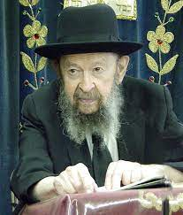

**QUESTION:** Must one undergo a special spiritual preparation in order to go to Eretz Yisroel?

**ANSWER:** And the answer is, absolutely! Yermiyahu Hanavi said in the name of Hashem, ותבאו ותטמאו את ארצי – “You came and you defiled My land” (Yermiyahu 2:7). And therefore,  it is of the utmost importance that someone should be ready to behave if he wants to go to Eretz Yisroel. He should learn how to conduct himself perfectly al pi hatorah before he goes to Eretz Yisroel. And even if he is good here,  he must make a resolve to be even better there. There are no two ways about that. It’s Eretz Hakodesh and it’s only for Jews who live b’kedusha.

Now you’ll ask me, what about the Arabs? First of all, the Arabs don’t ask us any questions. They’re not asking me for my opinion. And second is that an Arab, we consider him just like a bird. The birds who fly into Eretz Yisroel don’t have to have any kedusha. An Arab or a gentile doesn’t have any tumah. It’s like nothing to us. It’s like the grass that grows there.

But the Am Yisroel is a different story. They are pogem, they cause damage. When they do a sin they cause great harm in the world. And therefore, it’s of the utmost importance that a Jew, before he goes to Eretz Yisroel, must make up his mind to be there b’kedusha. Even if it’s just for a visit. Nobody should go unless he’ll go b’kedusha. If he takes along his wife, he must make sure that she’s dressed completely properly because this is a land that will vomit out the people who live there if they don’t suit its taste.

The land of Eretz Yisroel has to have something made to its taste. It’s a land of ותקיא הארץ את יושביה – And the land will vomit out its inhabitants (Achrei Mos 18:25). Eretz Yisroel is finicky. It’s a delicate land and only those people who behave properly can please the land.

*Reprinted from a recent Toras Avigdor email based on Rabbi Miller’s Tape # 200 from a classic Thursday night lecture in January 1977.*

**More Thoughts that Count**

**For Our Parsha**

*But on the seventh day is the Shabbat of rest, a holy convocation* (Lev. 23:3)

According to the Midrash, the Torah was worried about being neglected once the Jews entered the Land of Israel. "Master of the Universe!" it cried. "What is going to happen to me? Everyone will be busy sowing and planting..." G-d, however, assuaged its fears. "I am giving you a special partner," He said, "and that is the Shabbat, when the Jews are free from work. On that day they will gather in the synagogues and study halls to engage in study."

*And you shall count unto yourselves from the morrow after the day of rest* (Lev. 23:15)

In our times the counting of the omer is a Rabbinic decree, as without a physical Holy Temple in Jerusalem we obviously cannot bring the omer offering. That is why we conclude our counting with the words "May the Merciful One restore the Holy Temple to its place, speedily in our day": When Moshiach comes and the Temple is rebuilt, the omer offering will be reinstated. *(Yalkut Yitzchak)*

**How Do You Love Your Neighbor Like Yourself?**

**By Rabbi Efrem Goldberg**

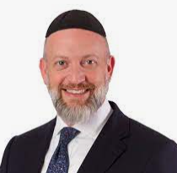

***Cut through the differences and focus on your shared commonality. Believe it or not, deep down it’s there.***

Rabbi Aryeh Levin was known as the righteous man of Jerusalem. He was incredibly pious, kind, and a great scholar. He lived in the quaint area of Nachlaot, right behind the busy open market. There was a young man who grew up in the neighborhood whom Rabbi Aryeh knew well but he felt the boy was avoiding him.

One day, they bumped into each other in the narrow alleys of Nachlaot and Rabbi Aryeh confronted him and said, “I can’t help but feel you are avoiding me, tell me how are you?”

The young man sheepishly replied that it was true, he was avoiding the great rabbi as he had grown up observant but had chosen to walk away from observant life altogether.

He said, “Rebbe, I was so embarrassed to meet you since I have taken off my kippah and am no longer observant.”

Rabbi Aryeh took the young man’s hand into his own and said, “My dear Moshe. Don’t worry. I am a very short man. I can only see what is in your heart, I cannot see what is on your head.”

The Torah commands us to “[love your neighbor like *yourself*](https://aish.com/1-love-your-neighbor-as-yourself/) (in Hebrew the word “yourself” is “*Kamocha*”). That doesn’t mean love your neighbor as you love yourself, which is unrealistic, if not impossible.  It means love you neighbor—why? Because he or she is like you, similar to you.  You both possess the same spark of life, the same G-dly soul, you both have strengths and weaknesses, you both have virtues and faults, you both have things to be proud of and areas to work on.

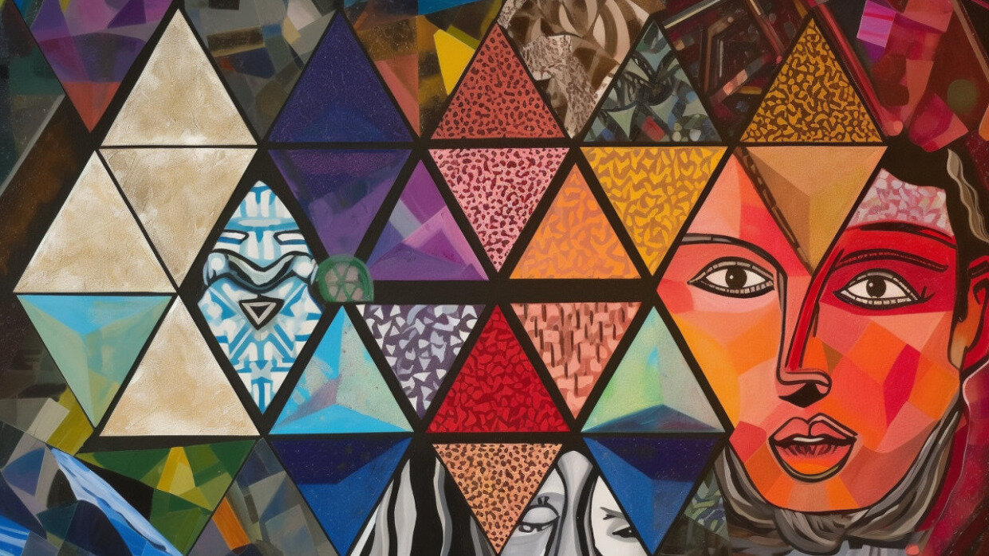

You can’t love others, certainly not all others as much as you love yourself, but you certainly can learn to love more.  How?  “Like yourself” – because if you can cut away their different kippah or their lack of a kippah, if you ignore how they dress differently, act differently, think differently, if you cut away their idiosyncrasies and habits that drive you crazy, you will find they are just like you.

The great Jewish sage [Rabbi Akiva witnessed thousands of his students fail this lesson](https://aish.com/48970241/). They focused on their differences rather than choose to embrace their similarities and the result was that they couldn’t see themselves in one another, they could not relate or identify. They saw their fellow student as different, the other, and that caused them to disrespect one another. Rabbi Akiva attended thousands of funerals and delivered thousands of eulogies as his students were cut down by a punitive plague and he turned around and taught, “’Love your neighbor like yourself’ is the primary principle of the Torah.

It is not a coincidence that the same Rabbi Akiva is quoted in Ethics of the Fathers, the Mishnaic collection of ethical sayings, as teaching, “How precious is every person because we were all created in the image of G-d.”  Internalizing that is the secret of loving everyone.

You may not have the capacity to love others as much as yourself, but you can do a whole lot better at loving others, especially those who are different than you, by focusing on how they are similar to you, despite their differences. Peel back the layers of that which separates you from others until you find common ground and that connects you. That is the full expression of loving your fellow Jew.

Reprinted from the April 27, 2023 posting on aish.com

**The Kavod (Honor) of a Kohen**

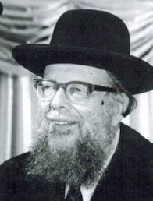

**Rabbi Shlomo Wolbe**

R’ Shlomo Wolbe z”l (1914-2005) teaches that most Parashot of the Torah have a theme. For example, the theme of last week’s Parashah was “Kedushah” / “holiness.”

The theme of this week’s Parashah, says R’ Wolbe, is “Kavod” / “honor”–honor of the Kohanim [21:1-9], honor of the Kohen Gadol [21:10-15], honor of the Bet Hamikdash and the Avodah / Temple service [21:16-22:31; 24:1-9], honor of Hashem’s Name [22:32-33; 24:10-22], and honor of Shabbat and Yom Tov [Ch.23]. R’ Wolbe elaborates:

The Creator is beyond our understanding. G-d is “Kadosh, Kadosh, Kadosh,” as we say in the first sentence of the Kedushah prayer–holier that we can comprehend. But, says the second sentence of Kedushah, “The earth is full of His Kavod / honor.”

Whatever Hashem chooses to reveal of Himself in our world, in order that we may revere Him, we call His “Honor.” Giving honor is, therefore, how we can connect to Him, and this week’s Parashah focuses on defining “honor” as the Torah views it. R’ Wolbe continues:

A person who does not give honor to other people demonstrates that he does not appreciate the greatness of man in general. The same is true of a person who does not honor himself, who lacks self-esteem, or who is overly self-deprecating; it is true even of a person who does not dress respectably.

Thus, the Gemara (Shabbat 113b-114a) refers to clothing as “that which gives me honor,” and says that a Torah scholar who has a stain on his clothing is deserving of the death penalty.

However, our Sages are not telling us to seek superficial displays of honor, like a seat at the eastern wall of the Shul. Rather, we should seek honor that reflects the holiness of G-d and of man’s soul. (Shiurei Chumash - Hamaayan)

*Reprinted from the Parshat Emor 5783 email of R’ Yedidye Hirtenfeld’s whY I Matter parsha sheet for the Young Israel of Midwood in Brooklyn.*

**Why is Israel Called the**

**Land of "Milk and Honey"?**

**By**[**Menachem Posner**](https://www.chabad.org/search/keyword_cdo/kid/12145/jewish/Posner-Menachem.htm)

Some of our greatest sages asked the same question; let's see what they have to say:

When G‑d spoke to Moses at the burning bush, He informed him that He would redeem the Israelites and bring them to a "good and spacious land, a land flowing with milk and honey..."[1](javascript:doFootnote('1a624194');) Honey here (and elsewhere in the Scriptures) is generally understood to be a reference to fruit nectar, specifically date honey—not bees' honey.

1) Nachmanides[2](javascript:doFootnote('2a624194');) writes that the key word in the verse is "flowing." Fruit trees grow in many different terrains, but their produce overflow with nectar only when the land is especially fertile, when the trees are particularly well-nourished.

Similarly, livestock survives in many habitats, but only overflow with milk when they are in particularly fertile pastures.

Thus, a "land flowing with milk and honey" is indicative and symptomatic of a greater good—the fertility of the Promised Land.

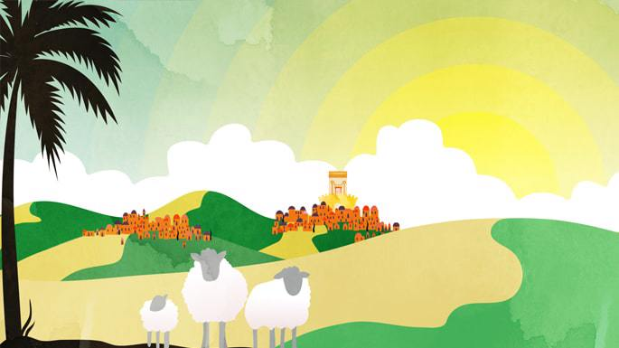

***Art by***[***Sefira Lightstone***](https://www.chabad.org/3159160)

2) The Midrash[3](javascript:doFootnote('3a624194');) explains that milk symbolizes superior quality, richness of taste, and nourishment. Honey represents sweetness. The goodness of Israel is both nourishing and pleasant.

3) Some point out that honey and milk share a paradoxical quality. Honey is kosher, though it is produced by a non-kosher insect. Milk is [kosher](https://www.chabad.org/library/article_cdo/aid/113424/jewish/Kosher.htm), though it comes from a cow whose meat may not be eaten together with milk.

The goodness of Israel will often times come from places where it is least expected.

**FOOTNOTES**

[1.](https://www.chabad.org/library/article_cdo/aid/624194/jewish/Why-Is-Israel-Called-the-Land-of-Milk-and-Honey.htm" \l "footnoteRef1a624194) [Exodus 3:8](https://www.chabad.org/9864#v8). [2.](https://www.chabad.org/library/article_cdo/aid/624194/jewish/Why-Is-Israel-Called-the-Land-of-Milk-and-Honey.htm#footnoteRef2a624194) Ibid. [3.](https://www.chabad.org/library/article_cdo/aid/624194/jewish/Why-Is-Israel-Called-the-Land-of-Milk-and-Honey.htm#footnoteRef3a624194) Yalkut Shimoni [Proverbs 8:943](https://www.chabad.org/16379#v943).

*Reprinted from the current website of Chabad.Org*